**Interfacing HC-SR04 Ultrasonic Sensor with ESP32 Devkit v1**

**INTRODUCTION**

Ultrasonic sensors are versatile and widely used devices that employ sound waves to detect the distance, presence, or movement of objects. These sensors work by emitting ultrasonic sound waves—high-frequency waves beyond the range of human hearing—from a transmitter. When these waves hit an object, they bounce back, and the sensor’s receiver captures the reflected waves. By calculating the time taken for the echo to return, the sensor determines the distance to the object with remarkable precision.

One popular example of an ultrasonic sensor is the HC-SR04, a commonly used module in robotics and electronics projects. This sensor is capable of measuring distances ranging from 2 cm to 400 cm (0.8 inches to 157 inches) with an impressive accuracy of 0.3 cm (0.1 inches). It is equipped with both a transmitter and a receiver, enabling it to provide reliable performance across various environments.

Ultrasonic sensors are commonly used in a wide array of daily life applications, making them indispensable in modern technology. For example, in automotive systems, these sensors are employed in parking assist technologies to help drivers gauge the proximity of their vehicles to obstacles. In home automation, ultrasonic sensors play a vital role in motion detection for lighting control or security systems. They are also used in industrial settings for tasks like liquid level measurement, proximity sensing, and object detection in assembly lines.

Moreover, ultrasonic sensors are integral to healthcare technologies, such as in diagnostic tools like ultrasound imaging devices. These devices use ultrasonic waves to produce real-time images of internal body structures, aiding in accurate medical diagnoses. Additionally, ultrasonic sensors are often found in cleaning systems, where high-frequency waves are used to remove dirt and debris from delicate objects.

The simplicity and efficiency of ultrasonic sensors have made them a favorite among hobbyists and professionals alike. From creating obstacle-avoiding robots to designing touchless devices for COVID-safe interactions, the applications of ultrasonic technology are virtually limitless. By harnessing the principles of sound propagation and echo detection, ultrasonic sensors continue to shape innovative solutions across industries and in our daily lives.

What is an Ultrasonic ?

Ultrasound refers to high-pitched sound waves that have a frequency beyond the range of human hearing. Unlike audible sound waves, which fall within the range of 20 Hz to 20,000 Hz, ultrasonic waves vibrate at frequencies above 20,000 Hz (20 kHz), making them imperceptible to the human ear. The term "ultrasound" originates from this distinct property of exceeding the upper limit of human auditory perception.

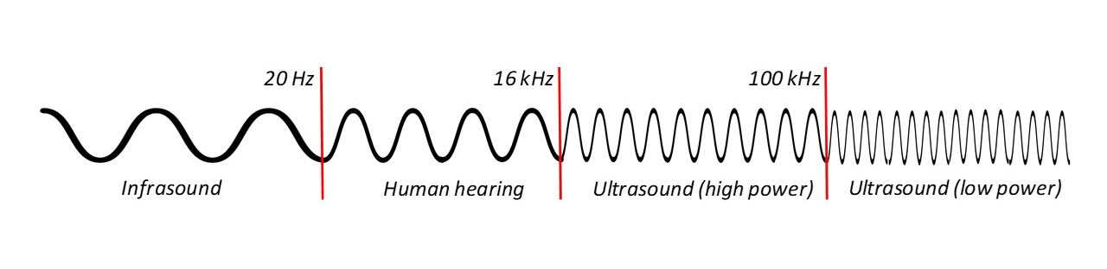

**Understanding the Ultrasonic Frequency Spectrum**

The spectrum of sound frequencies can be broadly divided into three categories:

1. **Infrasonic** (below 20 Hz): Extremely low frequencies, such as those produced by natural phenomena like earthquakes or volcanic eruptions.
2. **Audible** (20 Hz to 20,000 Hz): The range of sound that humans can hear, encompassing everything from a deep rumble to a sharp whistle.
3. **Ultrasonic** (above 20,000 Hz): High-frequency sound waves that are inaudible to humans but are detectable by certain animals and useful in various technological applications.

Ultrasonic waves are further categorized based on their frequency. For instance, medical ultrasound devices typically operate in the range of 1 MHz to 15 MHz, while industrial ultrasonic systems can exceed frequencies of 50 MHz.

**Significance of Ultrasonic Waves**

Ultrasonic waves have unique properties that make them invaluable across numerous fields. Their high frequency enables precise interactions with matter, such as penetrating solid objects, detecting minute details, and transmitting energy with minimal loss. These characteristics have paved the way for their application in medicine, industry, electronics, and even wildlife studies.

For example, bats and dolphins use ultrasonic frequencies for echolocation, enabling them to navigate and hunt with remarkable accuracy in their environments. This natural phenomenon has inspired human innovations, such as ultrasonic sensors for distance measurement and sonar systems for underwater exploration.

The concept of ultrasonic waves and their frequency spectrum underscores the fascinating capabilities of sound beyond human perception, offering powerful tools to solve problems and improve daily life.

Hardware Overview

**HC-SR04 Ultrasonic Sensor**

The HC-SR04 ultrasonic sensor is a widely used and highly reliable module for non-contact distance measurement in electronics projects. It works using two ultrasonic transducers: one functions as a transmitter that emits sound waves at a frequency of 40 kHz, while the other acts as a receiver to detect the reflected waves (echo) from an object. The sensor determines the distance to the object by calculating the time taken for the echo to return to the receiver. Its operating range spans from 2 cm to 400 cm (~0.8 inches to 13 feet), with an impressive accuracy of ±3 mm (0.1 inches), making it suitable for precision-based tasks. The HC-SR04 operates on 5V and features a simple pin interface with Trigger and Echo pins, allowing easy integration with microcontrollers like Arduino or ESP32. The sensor’s versatility and affordability make it a staple in applications such as robotics, object detection, obstacle avoidance, and distance measurement systems.

The following picture shows the HC-SR04 ultrasonic sensor:

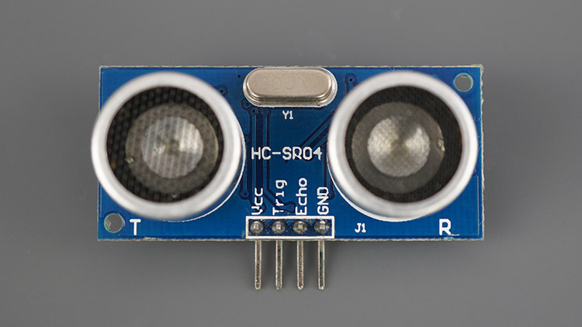

The next picture shows the other side of the sensor.

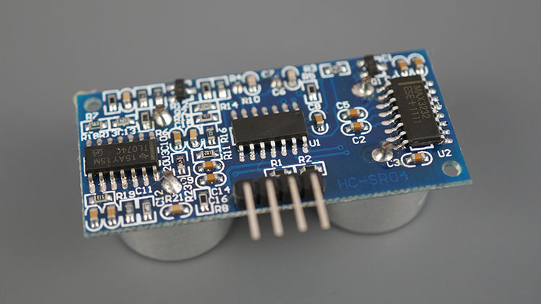

**Key Features**:

* **Wide Measurement Range**: Measures distances from 2 cm to 400 cm (~0.8 inches to 13 feet).
* **High Accuracy**: Delivers precise readings with an accuracy of ±3 mm (0.1 inches).
* **Non-Contact Measurement**: Ideal for detecting objects without physical contact.
* **Simple Interface**: Features Trigger and Echo pins for straightforward communication with controllers.
* **Power Requirements**: Operates at 5V, compatible with most microcontrollers and development boards.
* **Compact and Lightweight**: Easy to integrate into compact systems and portable devices.
* **Applications**: Frequently used in robotics, home automation, industrial automation, and distance-aware IoT projects.

Technical Specifications and Pinouts

Here are the specifications:

|  |  |
| --- | --- |
| Operating Voltage | DC 5v |
| Operating Current | 15mA |
| Operating Frequency | 40KHz |
| Max Range | 4m |
| Min Range | 2cm |
| Ranging Accuracy | 3mm |
| Measuring Angle | 15 degrees |
| Dimension | 45 x 20 x 15mm |
| Trigger Input Signal | 10µs TTL pulse |

HC-SR04 Ultrasonic Sensor Pinout

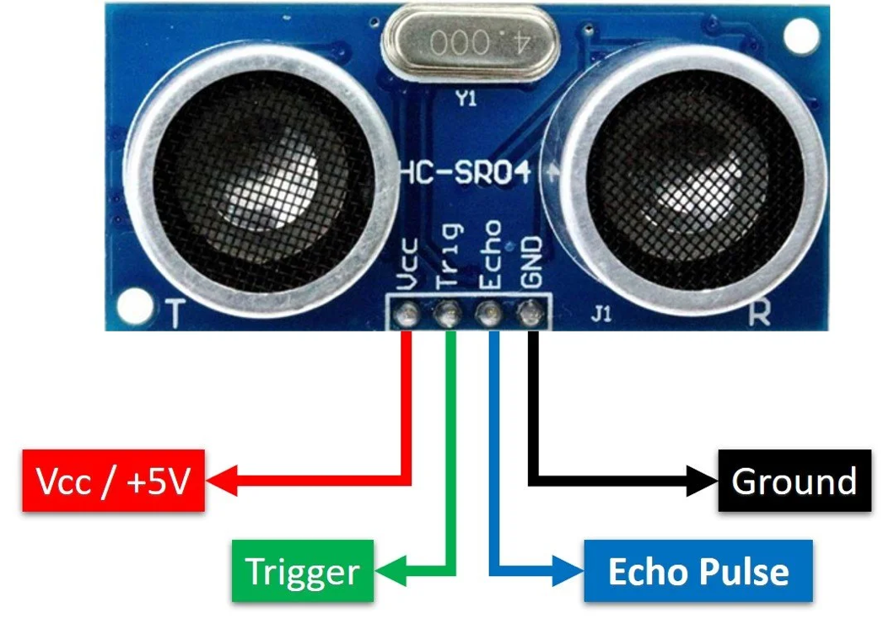

|  |  |  |
| --- | --- | --- |
| **Pin Number** | **Pin Name** | **About Pin** |
| 1 | VCC | Powers the sensor (5v) |
| 2 | Trig | Trigger Input Pin |
| 3 | Echo | Echo Output Pin |
| 4 | GND | Common GND |

1. **VCC -** supplies power to the HC-SR04 ultrasonic sensor. You can connect it to the 5V output from your Arduino or Vin pin on ESP32 devkit.
2. **Trig (Trigger) -** pin is used to trigger ultrasonic sound pulses. By setting this pin to HIGH for 10µs, the sensor initiates an ultrasonic burst.
3. **Echo -** pin goes high when the ultrasonic burst is transmitted and remains high until the sensor receives an echo, after which it goes low. By measuring the time the Echo pin stays high, the distance can be calculated.
4. GND - is the ground pin. Connect it to the ground of the Arduino or GND of ESP32 devkit.

How Does HC-SR04 Ultrasonic Distance Sensor Work?

The ultrasonic sensor works by emitting sound waves and measuring the time it takes for the waves to bounce back after hitting an object. The operation starts when a trigger pin is set HIGH for 10 microseconds (µs), which causes the sensor to transmit a burst of eight ultrasonic pulses at a frequency of 40 kHz. This pulse pattern helps the receiver differentiate the sensor’s transmission from ambient ultrasonic noise.

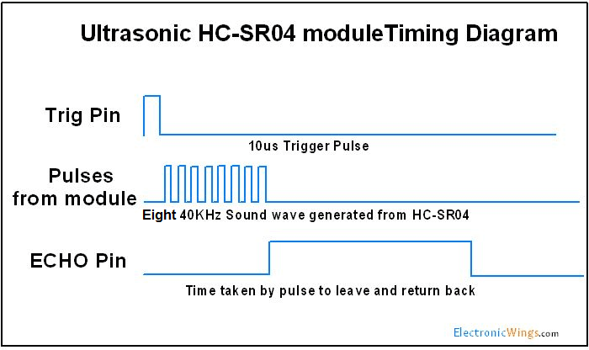

Once the pulses are sent, they travel through the air. Meanwhile, the echo pin is set HIGH, marking the beginning of the echo-back signal. If no object is within range to reflect the pulses, the echo signal will time out and go LOW after 38 milliseconds (ms). A timeout of 38 ms indicates there is no obstruction within the sensor's range.

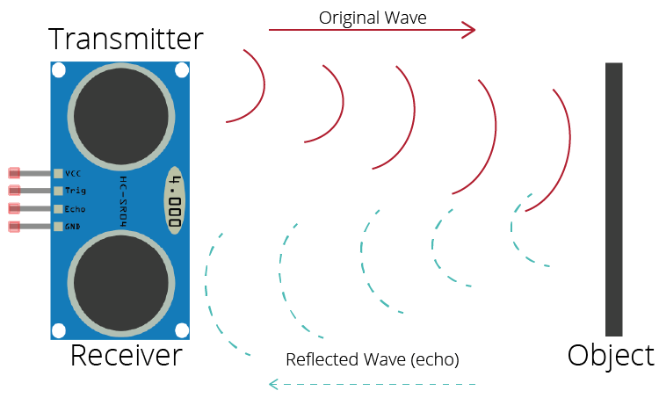

If the pulses are reflected back by an object, the echo pin will go LOW as soon as the signal is received. This produces a pulse on the echo pin, and its width depends on how long it took for the signal to travel to the object and back. The width of the pulse can vary from 150 microseconds (µs) to 25 milliseconds (ms) depending on the distance.

**Calculating the Distance**

To calculate the distance to the object, the width of the received echo pulse is used. This is based on the simple distance-speed-time relationship:

Distance=Speed×TimeDistance=Speed×Time

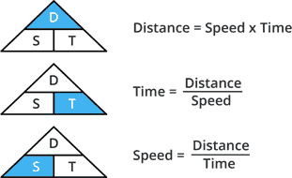

In this case, the speed of sound in air is used to calculate the distance. The speed of sound is approximately 340 meters per second (m/s), which we convert to centimeters per microsecond (cm/µs), giving a value of 0.034 cm/µs.

Let’s consider an example where the width of the received pulse is 500 µs. Using the equation, we can calculate the distance as follows:

1. **Speed of Sound**: 0.034 cm/µs
2. **Time (Width of Echo Pulse)**: 500 µs

Now, applying the formula:

Distance=0.034 cm/µs×500 µs=17 cmDistance=0.034cm/µs×500µs=17cm

However, we must remember that the pulse represents the time it takes for the signal to travel to the object and return to the sensor. Thus, the actual distance to the object is half of this value:

Distance=17 cm2=8.5 cmDistance=217cm​=8.5cm

So, the object is 8.5 cm away from the sensor.

Schematic Diagram

Circuit Diagram of connecting ESP32 to ultrasonic sensor HC-SR04

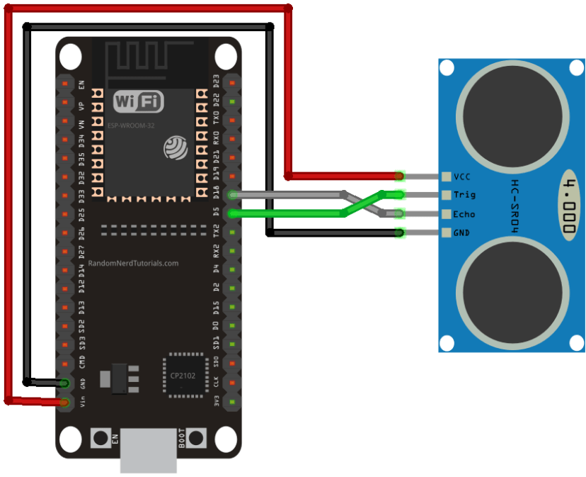

Wiring ESP32 devkit to HC-SR04 Ultrasonic Sensor

Connecting the HC-SR04 to ESP32 devkit v1 is very easy. Start by placing the sensor on your breadboard. Connect the VCC pin to the Vin pin on the ESP32 devkit v1 and the GND pin to the ground pin. Now connect the trig and echo pins to GPIO D5 and D18 respectively.

The following table lists the pin connections:

|  |  |
| --- | --- |
| HC-SR04 Sensor | ESP32 Devkit v1 |
| VCC | VIN |
| TRIG | D5 |
| ECHO | D18 |
| GND | GND |

Uploading Code

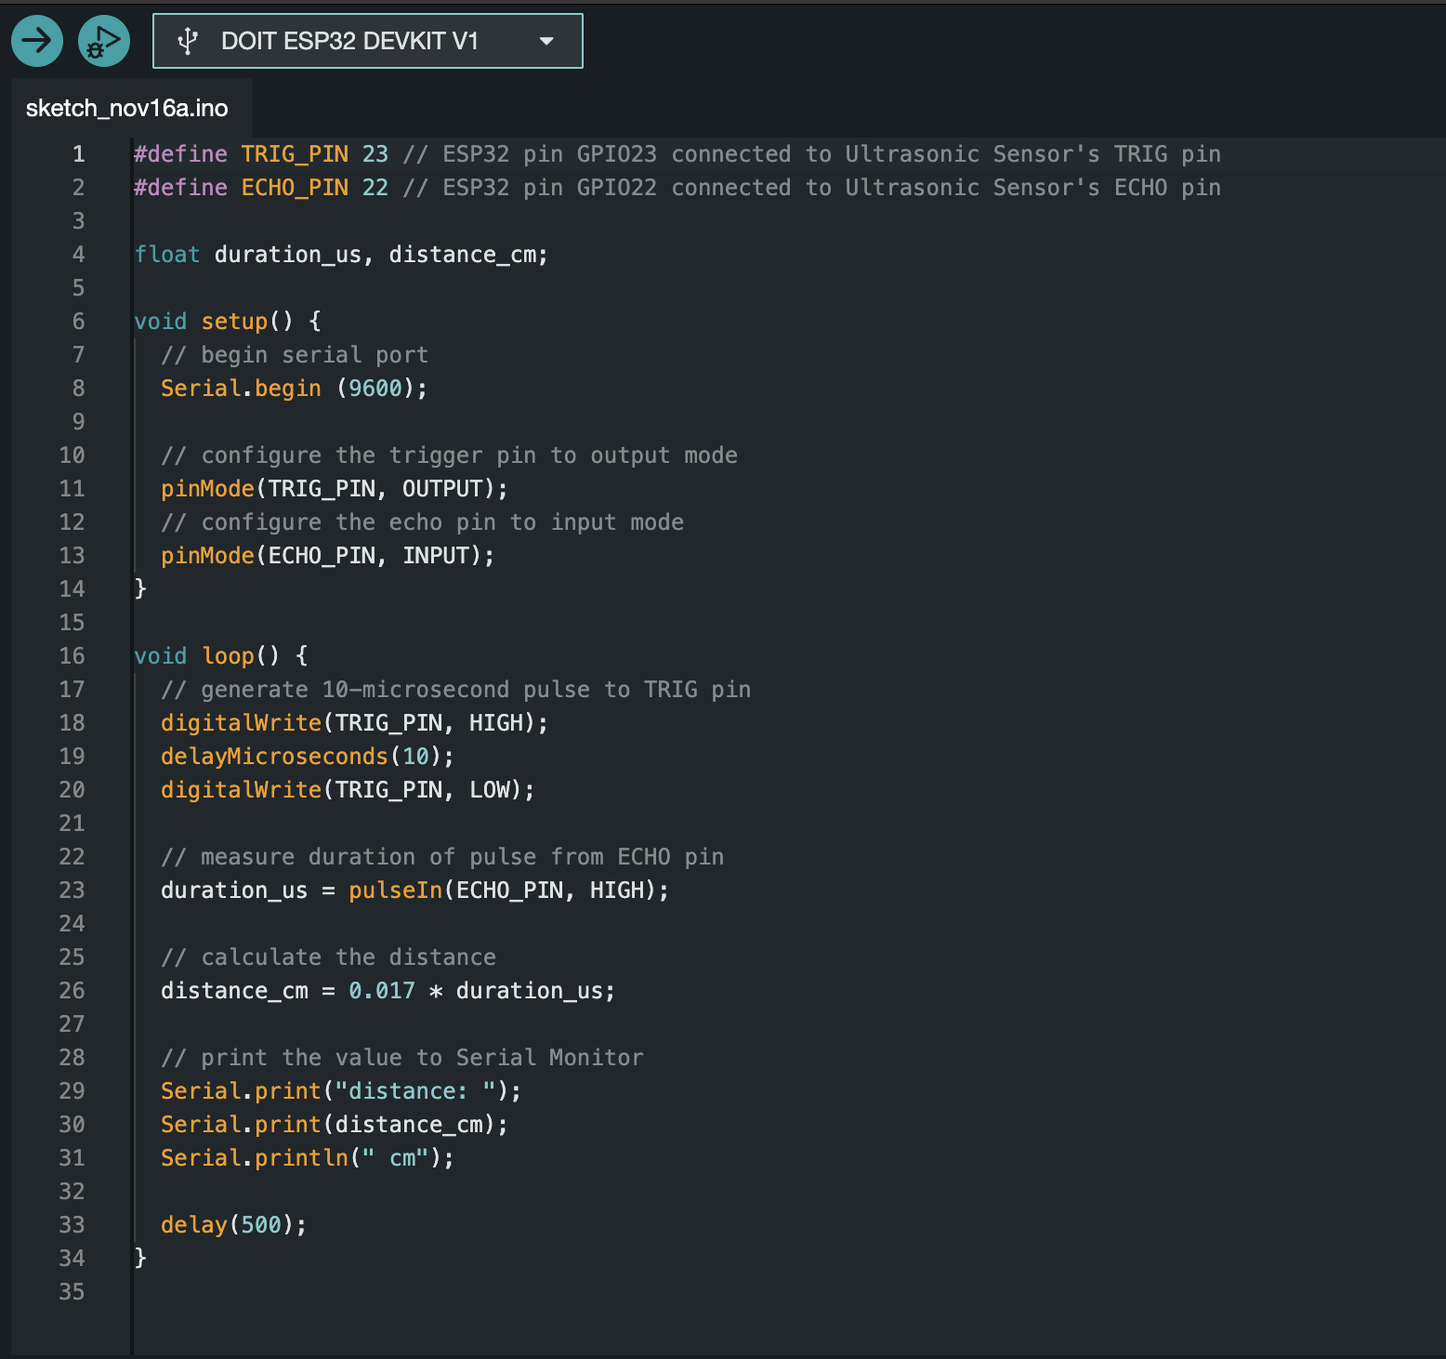

Output: 